讓我開心

Make me happy

在這個專案裡，我們會製作一個能依據你說的話作反應的角色

In this project you will make a character that reacts to what you say.

如果你稱讚他，他會表現出高興的樣子。

如果你罵他，他會表現出難過的表情。

If you compliment it, it will look happy.

If you insult it, it will look sad.

一開始，我們會先嘗試列規則的方式，列出哪些哪些詞語是善意的、哪些詞語是惡意的，並觀察為什麼這個方式效果不佳。

At first, you’ll program a list of rules for what is kind and what is mean, and learn why that approach isn’t very good.

接著，改用給範例的方法，讓電腦學習分辨哪些是善意的訊息，而哪些是惡意的。

Next, you will teach the computer to recognise kind messages and mean messages by giving it examples of each.

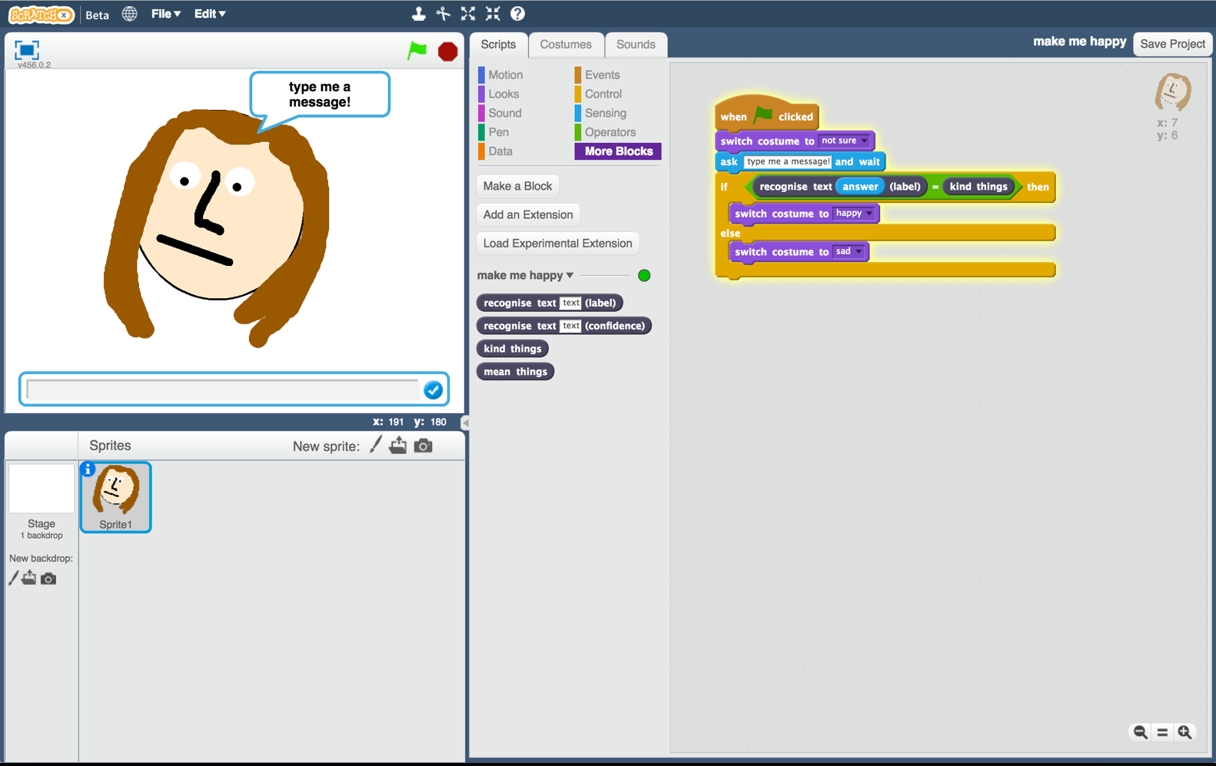

This project worksheet is licensed under a Creative Commons Attribution Non-Commercial Share-Alike License

http://creativecommons.org/licenses/by-nc-sa/4.0/

1. 搜尋網頁：<https://machinelearningforkids.co.uk/>

Go to <https://machinelearningforkids.co.uk/> in a web browser

1. 點選“**Get started**”

Click on “**Get started**”

1. 點選“**Try it now**”

Click on “**Try it now**”

1. 點選**“+ Add a new project**”

Click the **“+ Add a new project**” button.

1. 將你的專案命名為 “make me happy”並設定成辨識 “**text**”類別，點選 “**Create**”按鈕

Name your project “make me happy” and set it to learn how to recognise “**text**”.   
Click the “**Create**” button  
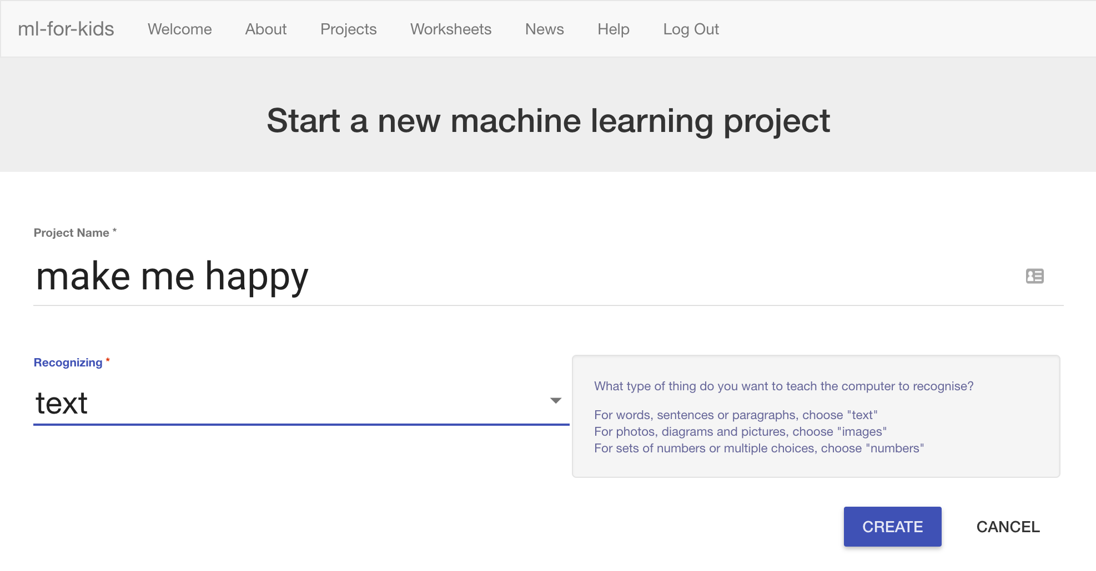

1. 你會在專案清單中看到“**make me happy**”，點選此專案

You should now see “**make me happy**” in the list of your projects. Click on it.

1. 你需要一些範例來訓練電腦。點選**Train**按鈕

You need examples to train the computer. Click the **Train** button.   
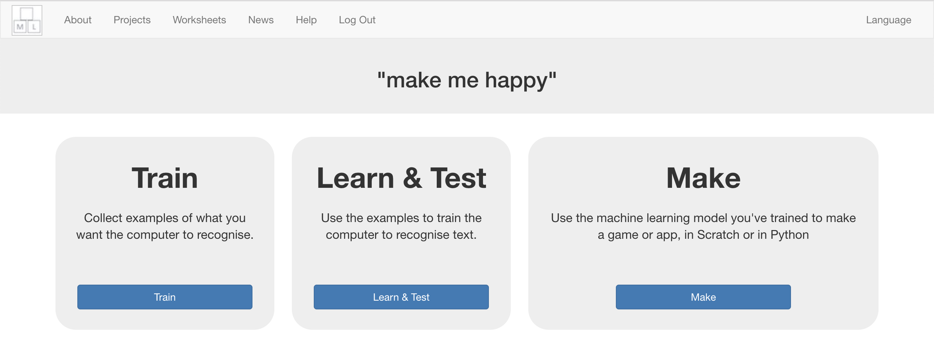

1. 點選**“+ Add new label**”，建立兩個新方框，一個命名為“kind things”，另一個命名為“mean things”。

Click on **“+ Add new label**” and call it “kind things”.   
Do that again, and create a second bucket called “mean things”.  
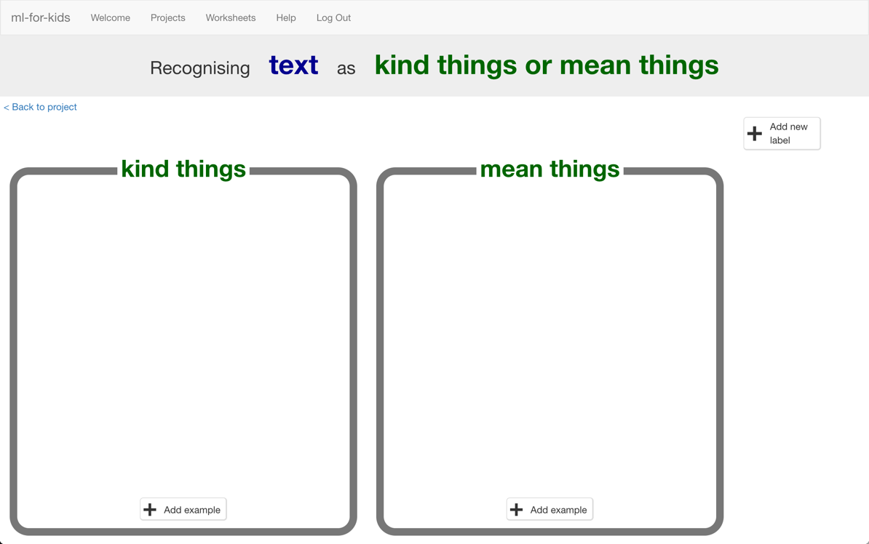

1. 點選“kind things”方框中的“**Add example**”按鈕，輸入一個善意的訊息

Click the “**Add example**” button in the “kind things” bucket, and type in a kind message.

1. 點選“mean things”方框中的“**Add example**”按鈕，輸入一個惡意的訊息

Click on the “**Add example**” button in the “mean things” bucket, and type in a mean message.

1. 重複步驟9和10，直到每個方框中都至少有**6**個範例訊息

Repeat steps 9 & 10 until you’ve got at least **six** examples of each.  
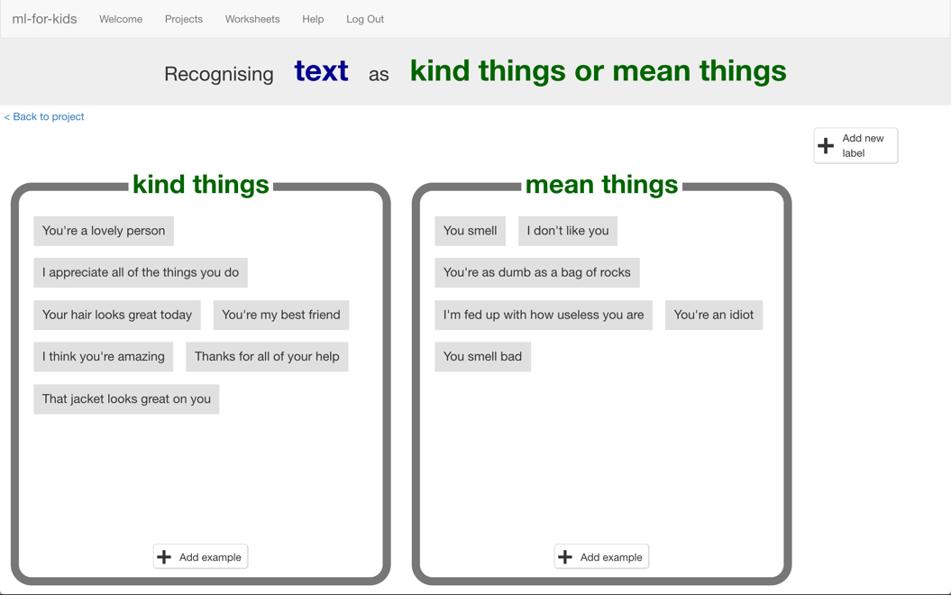

1. 點選**“< Back to project**”，再點選“**Learn & Test**”按鈕

Click on the **“< Back to project**” link.   
Then click on the “**Learn & Test**” button.

1. 點選“**Train new machine learning model**”按鈕

*只要蒐集夠多範例，電腦就可以開始學習辨別訊息*

Click on the “**Train new machine learning model**” button.   
*As long as you’ve collected enough examples, the computer should start to learn how to recognise messages from the examples you’ve given to it.  
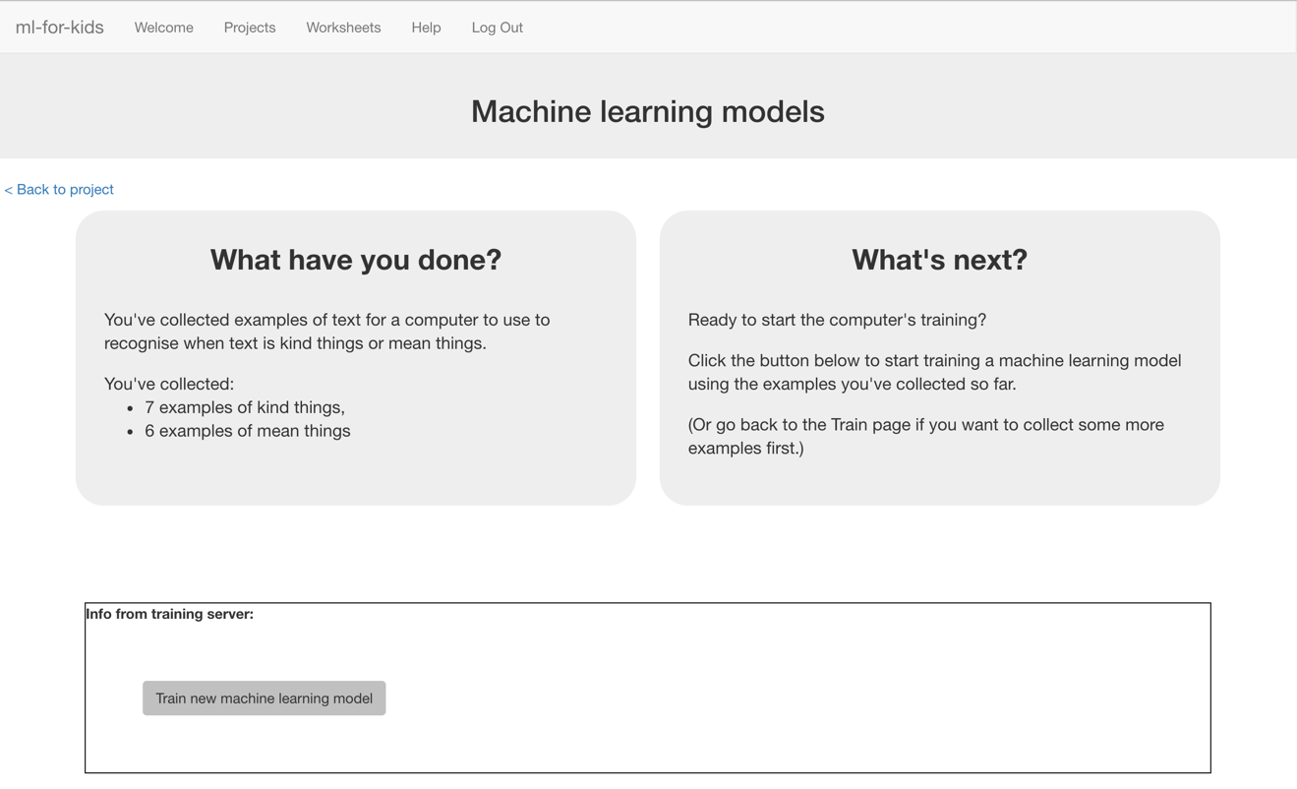*

1. 等待訓練完成，這可能需要幾分鐘的時間

Wait for the training to complete. This might take a few minutes.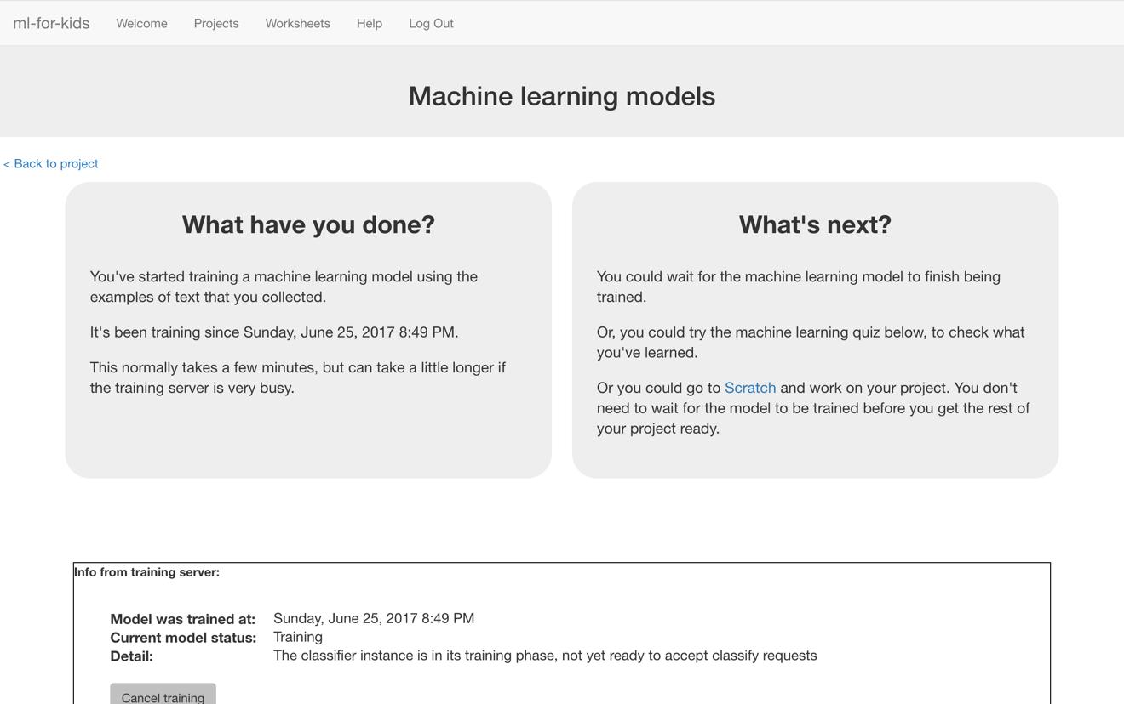

1. 當訓練完成後，會出現一個文字框。

測試一下這個模型，看看電腦學到些什麼。

輸入一些善意的訊息，按下enter，電腦應該能辨識為善意訊息。

輸入一些惡意的訊息，按下enter，電腦應該能辨識為惡意訊息。

*測試訊息必須要電腦之前沒看過的。*

*如果你對電腦辨識結果不滿意，回到步驟11，加入更多範例訊息，*

*記得重複步驟13，用新範例訊息訓練模型。*

Once the training has completed, a Test box will be displayed.   
Try testing your machine learning model to see what the computer has learned.   
Type something kind, and press enter. It should be recognised as kind.  
Type something mean, and press enter. It should be recognised as mean.  
 *Test it with examples that you haven’t shown the computer before.   
If you’re not happy with how the computer recognises the messages, go back to step 11, and add some more examples.   
Make sure you repeat step 13 to train with the new examples though!*

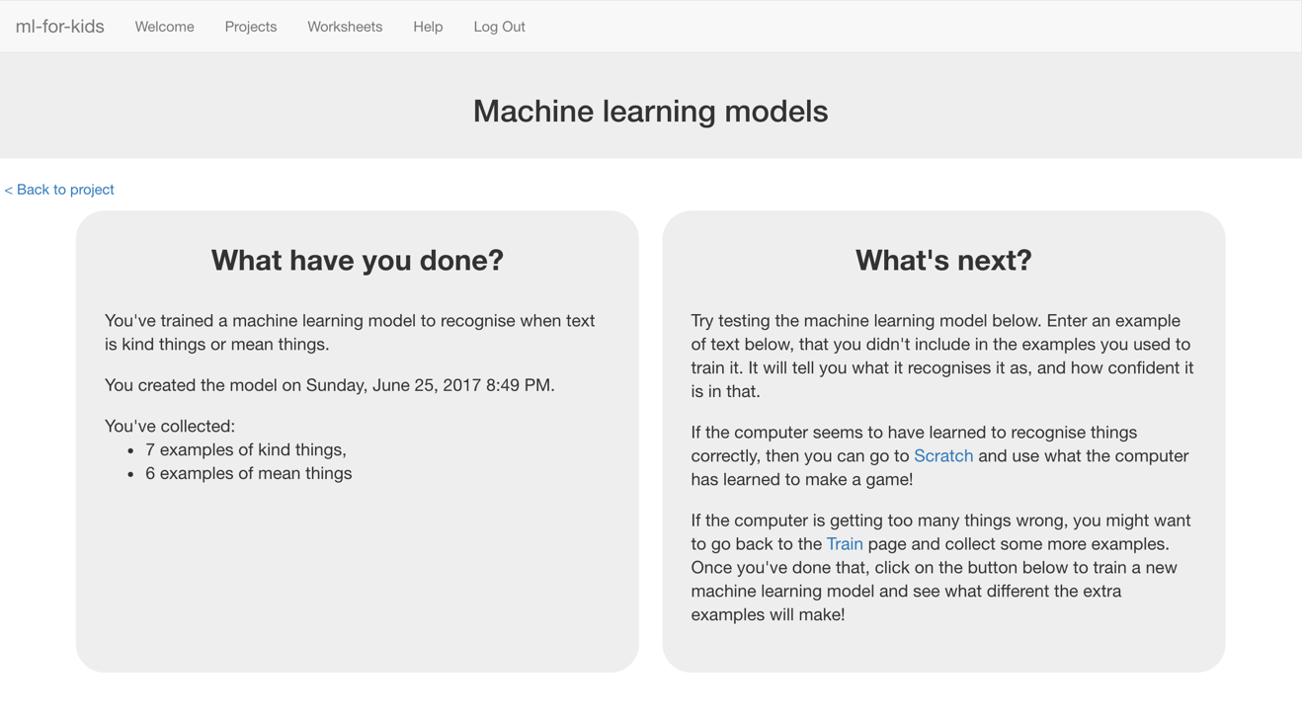

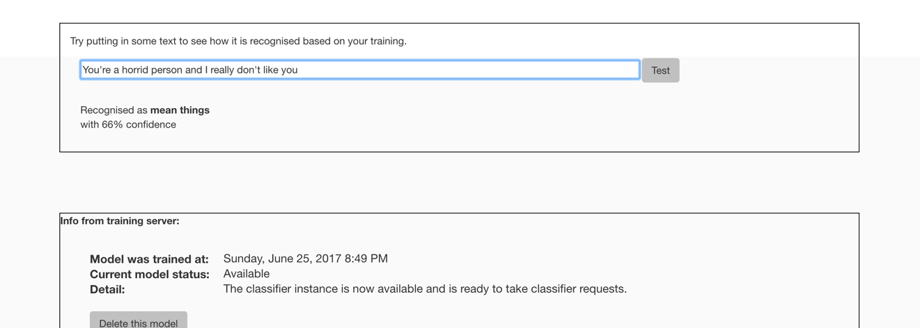

**到目前為止，你做了哪些事情？**

**What have you done so far?**

你已經開始訓練電腦辨別善意和惡意的訊息。我們不使用制定規則的方式，而是蒐集範例讓電腦學習。這些範例被用來訓練一個機器學習『模型』。

You’ve started to train a computer to recognise text as being kind or mean. Instead of trying to write rules to be able to do this, you are doing it by collecting examples. These examples are being used to train a machine learning “model”.

這就是所謂的『監督式學習』(supervised learning)，因為你給電腦訓練用的範例都確保是正確的，就像是在監督它一樣。

This is called “supervised learning” because of the way you are supervising the computer’s training.

電腦從範例中尋找共通的模式，例如文字與撰寫風格。這些會被用來辨識新訊息。

The computer will learn from patterns in the examples you’ve given it, such as the choice of words, and the way sentences are structured. These will be used to be able to recognise new messages.

1. 點選**“< Back to project**”

Click the **“< Back to project**” link

1. 點選“**Make**”按鈕

Click the “**Make**” button

1. 點選“**Scratch**”按鈕

*此頁有如何使用Scratch新積木的教學，如果你有需要可以參考。*

Click the “**Scratch**” button.   
*This page has instructions on how to use the new blocks in Scratch.   
Keep the page open if you need to check back on how to use them.*

1. 點選“**Open in Scratch**”按鈕，你會在專案裡的『更多積木』(More blocks)區看到新積木。

Click the “**Open in Scratch**” button   
*You should see blocks in “More blocks” from your project.*  


1. 點選角色區的『畫筆』，畫一個新角色。

*Scratch中有很多個相似的畫筆按鈕，確認你選擇的是正確的按鈕。*

Create a new sprite by clicking the paintbrush icon in the Sprites window.   
*There are a few similar looking paintbrush buttons – make sure you click the one marked below.*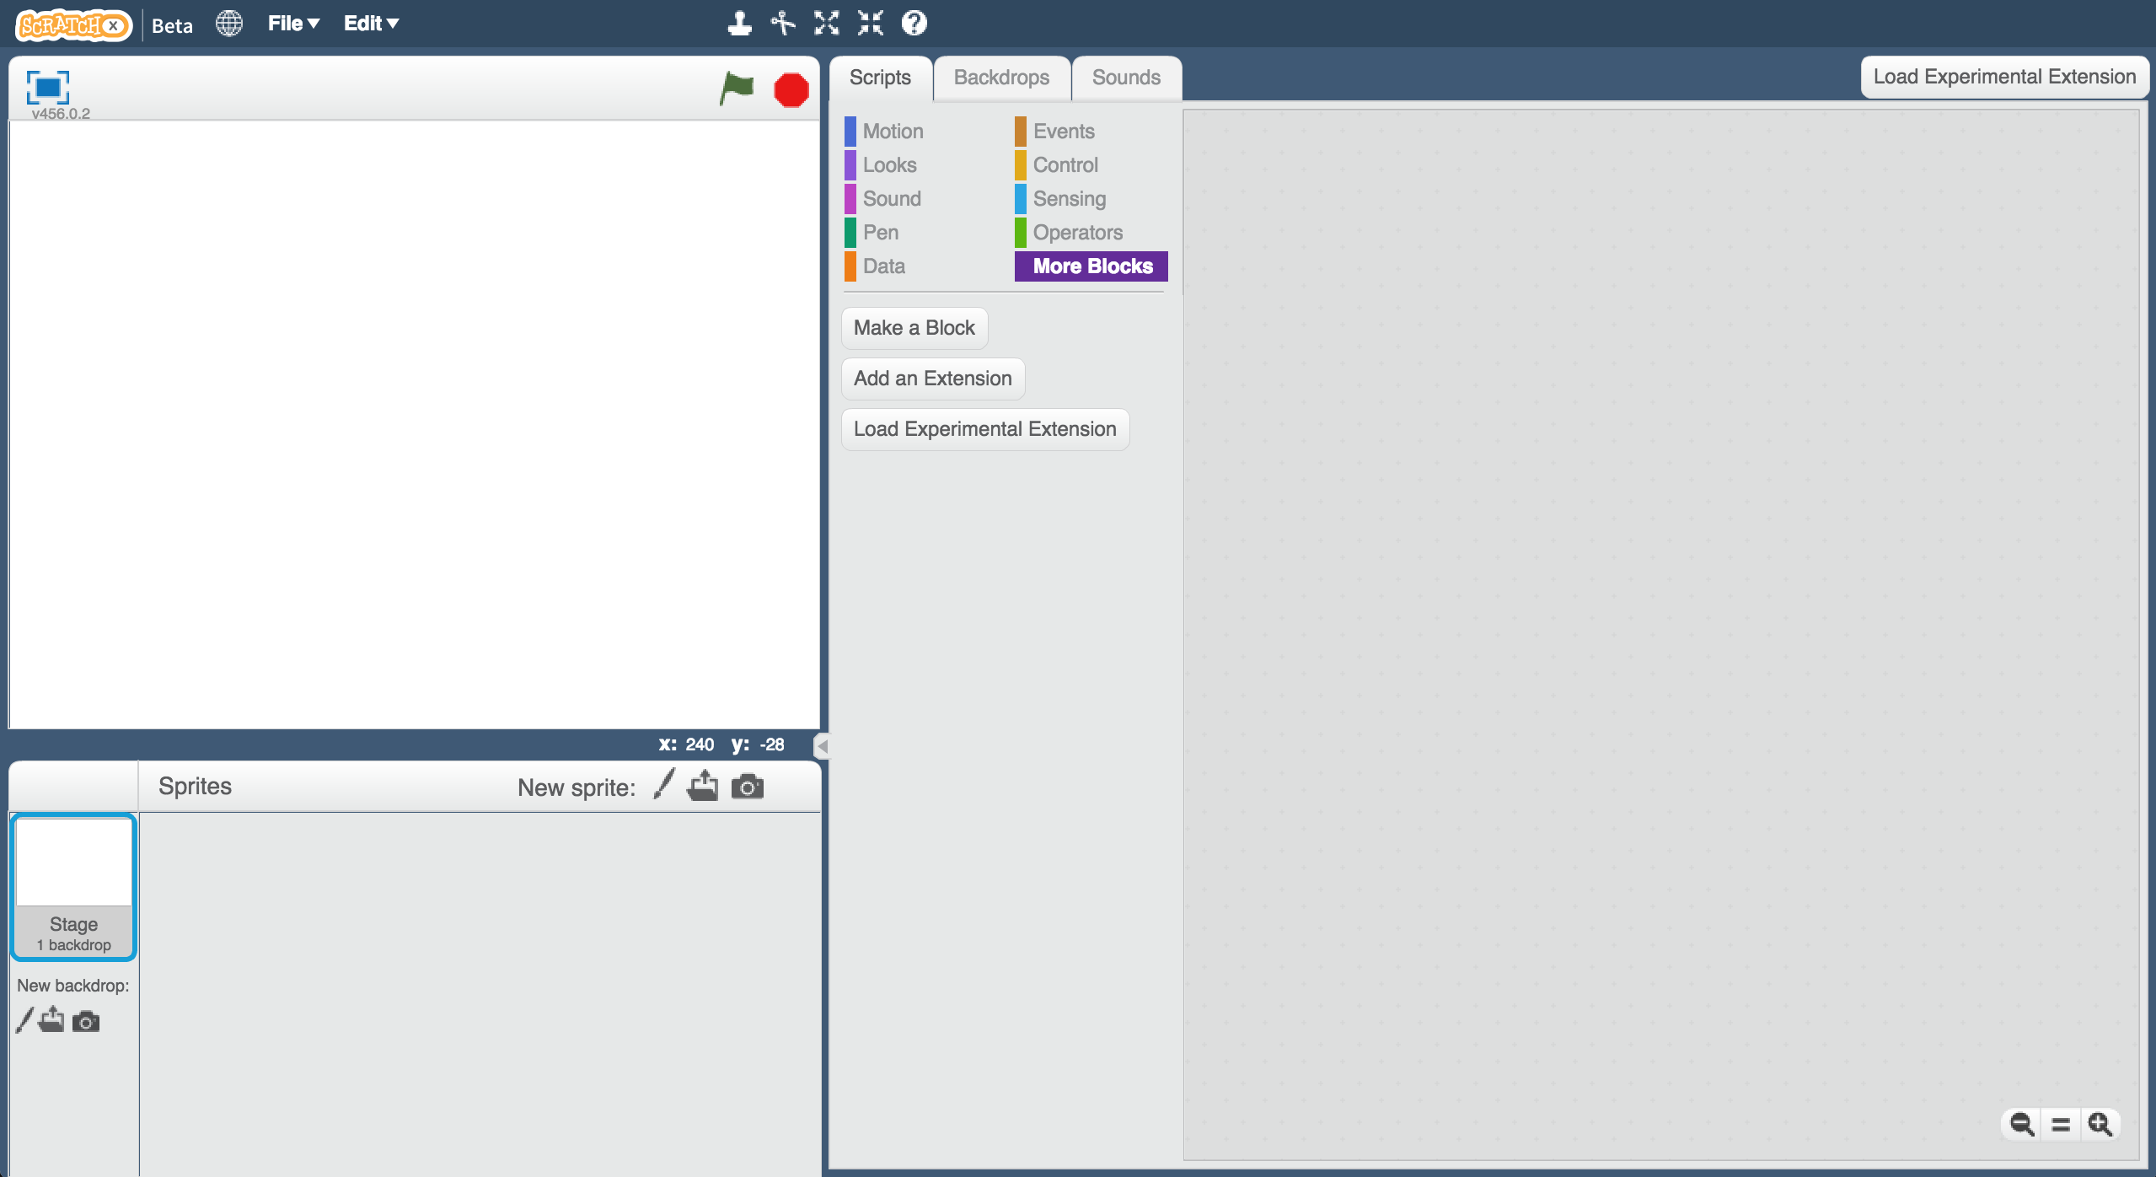

1. 在右方的畫布區畫一張沒有嘴巴的臉

Draw a face, without a mouth, in the sprites editor on the right.   


1. 在造型上點右鍵，選擇『複製』。

再複製一次，到目前為止你應該會有三個長得一樣的造型。

*確認你是複製『造型』，而不是複製『角色』，如果你不確定，請詢問你的老師*

Right-click on the costume, and click “Duplicate”.   
Do that again so you have **three** copies of the costume.   
  
*Make sure you are duplicating the costume,* ***not*** *the sprite.   
Ask your teacher if you’re not sure.*   
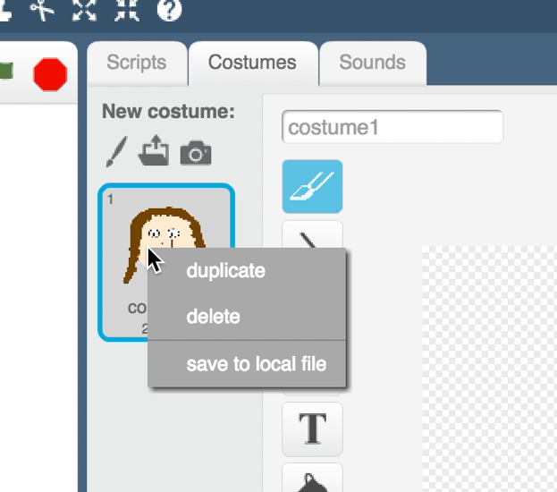

1. 將三個造型分別命名成“not sure”、 “happy”和“sad”。

Name the three costumes “not sure”, “happy” and “sad”  
*Type the names into the white box shown by the arrow below.*   


1. 幫每個造型畫上嘴巴。

*造型“not sure”畫上一條橫線，造型“happy”畫上一個微笑，造型“sad”則畫上悲傷的表情。*

Draw a mouth on each of the costumes.   
*The “not sure” face should be a straight line.   
The “happy” face should have a smile.   
The “sad” face should look sad.*  


1. 點選『程式』，拖曳程式積木（如下圖）

*“recognise text … (label)”是此專案新增的積木，當你給他一段訊息，他會根據先前的訓練辨別這條訊息是善意或是惡意的。我們利用這個積木來決定角色要擺什麼表情。*

Click the “**Scripts**” tab, and enter the following script.  
*The “recognise text … (label)” block is a new block added by your project. If you give it text, it will recognise it as “kind things” or “mean things” based on the training you’ve given to the computer.   
You can use this to choose the costume to switch to.*  
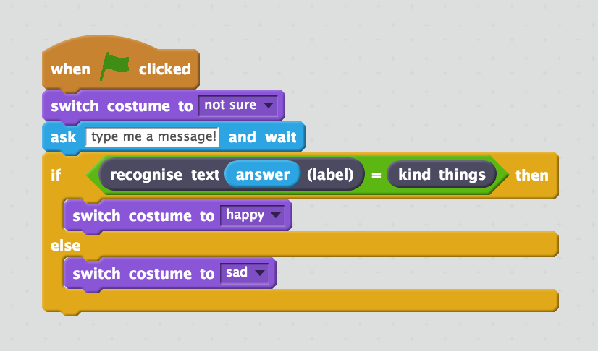

1. 點擊綠旗

Click the **green flag** to test. 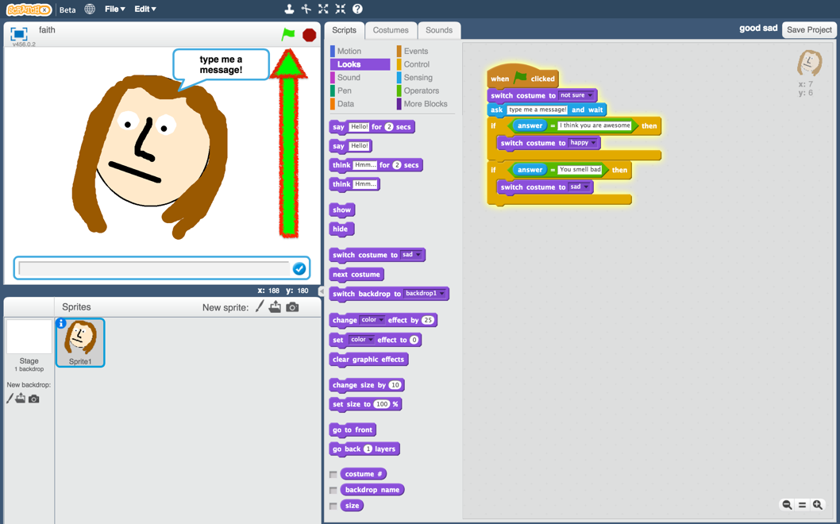

1. 輸入一條訊息並觀察結果！

*輸入一條善意的訊息，角色應該會微笑。*

*再次點擊綠旗，這次輸入一條惡意訊息，角色應該會擺出悲傷的表情。*

Type in a message and watch it react!  
*Type a kind message and press enter. The character should smile.   
Click the green flag again. Type a mean and unkind message and press enter. The character should look sad.****This should work for messages that you didn’t include in your training.***

**到目前為止，你做了哪些事情？**

**What have you done?**

你已經開始訓練電腦辨別善意和惡意的訊息。我們不使用制定規則的方式，而是蒐集範例讓電腦學習。這些範例被用來訓練一個機器學習『模型』。

You’ve started to train a computer to recognise text as being kind or mean. Instead of trying to write rules to be able to do this, you are doing it by collecting examples. These examples are being used to train a machine learning “model”.

這就是所謂的『監督式學習』(supervised learning)，因為你給電腦訓練用的範例都確保是正確的，就像是在監督它一樣。

This is called “supervised learning” because of the way you are supervising the computer’s training.

電腦從範例中尋找共通的模式，例如文字與撰寫風格。這些會被用來辨識新訊息。

The computer will learn from patterns in the examples you’ve given it, such as the choice of words, and the way sentences are structured. These will be used to be able to recognise new messages.

**延伸活動**

**Ideas and Extensions**

現在你已經完成了這個專案，要不要試試下面這些點子？或者想出其他點子？

Now that you’ve finished, why not give one of these ideas a try?

Or come up with one of your own?

**回覆訊息**

**Write a reply**

除了改變表情，試著讓你的角色依據訊息給出不同的回覆吧！

Instead of just changing the way they look, make your character reply, based on what it recognises in the message!

**試試其他角色**

**Try a different character**

除了人臉，要不要試試看其他不一樣的臉，比如動物的臉？

Instead of a person’s face, why not try something different, like an animal?

舉例來說，你可以選擇小狗，當他辨識到善意的訊息時就會搖尾巴！

For example, you could make a dog that wags their tail if you say something kind to it!

**使用信心分數 (confidence score)**

**Use the confidence score**

專案裡還有其他積木可以對辨別結果的把握程度給出一個分數。你可以怎麼使用這個積木來處理那些既非善意也非惡意的訊息呢？

The other new Scratch block from your project gives the score for how sure your machine learning model is that it has recognised the message. How can you use this for messages that aren’t compliments or insults?

**真實情緒分析**

**Real world sentiment analysis**

你能想出一些範例，可以訓練電腦有效辨識出文字中的情緒嗎？

Can you think of examples where it’s useful to be able to train a computer to recognise the emotion in writing?